Most important thing of Software development is request response model.

Request: 4 types

1. Get request: medium.com e giye ekta blog e click kore request kora
2. Post request: fb te post kora. Medium e blog lekha
3. Update request: post edit kora. Comment edit
4. Delete request: post delete kora. Nijer ta nije ba admin authorization.

Authorization/restriction: ke kar post dekhte parbe. Ekjoner post arekjon update/delete korte parbe kina

If we make a website that has these 4 operations, we call it CRUD project.

C – Create

R – Retrieve/Read

U – Update

D – Delete

We send these requests to Database or server. Request goes from frontend to backend(database/server).

Django is a backend framework. Request Handler. Request goes to backend from frontend through URL which is defined in the backend. When a request is send to backend Django-views handle kore.

Main khela holo request response er khela.

**Introduction to Django:**

What is Django?

Django is web application framework written in Python programming language. It is based on MVT (model view template) design pattern.

It is also called batteries included framework because Django provides built-in features for everything.

* Why Django framework?
* Excellent documentation and high scalability. 100k user use korleo fast thake
* Used by top MNCs like insta, Spotify, Youtube, Bitbucket, Dropbox etc.
* Easiest framework to learn, rapid development and Batteries fully included. Django er sob code mainly oop diye develop kora.
* One can integrate it with Web Scraping, Machine Learning, Image Processing, Scientific Computing etc web application and do lots and lots of advance stuff.

How does Django work?

MVT is a design pattern that separates an application into three main logical components Model, View, Template.

User Django app e click kore url diye. Url to View (file,functions) to Model(database) theke data niye View te back ashe and next Template(frontend er page or design) e data gula bosai View te jai, VIew frontend e Template ta render kore.

Model: the data we want to present, usually data from database.

View: A request handler that returns the relevant template and content – based on the request from the user.

Template: it represents how data should be presented to the application user. It may consist of HTML, CSS, JS mixed with Django Template Language.

Unique features of Django:

* Admin Interface
* ORM: Object Relational Mapping. Database related code likhbo python e, convert hoye jabe Database er code(sql) e
* URL routing
* Template System
* Form Handling
* Security Features
* Scalability

Virtual Environment: is a tool that helps to keep dependencies required by different projects separate by creating isolated python virtual environments for them.

Test: pipenv –version

Name: python -m venv name

Activate: <venv>\Scripts\activate.bat

Deactivate: deactivate [kaj seshe lock kore rakhbo jate data leak na hoi]

To install specific version of Django: pip install django==4.1.9

New project er age cd kore venv er folder tai jete hobe

New project: Django-admin startproject name

cd project_1 //change directory

python manage.py runserver

ekta link thakbe jate gele successful lekha ashte hobe. Link er sheshe admin/ add korle admin interface ta ashbe.

**Django project Directory Structure**

Project-name: bairer folder ta holo outer project folder or root directory

Same name e vitorer ta holo: inner project folder

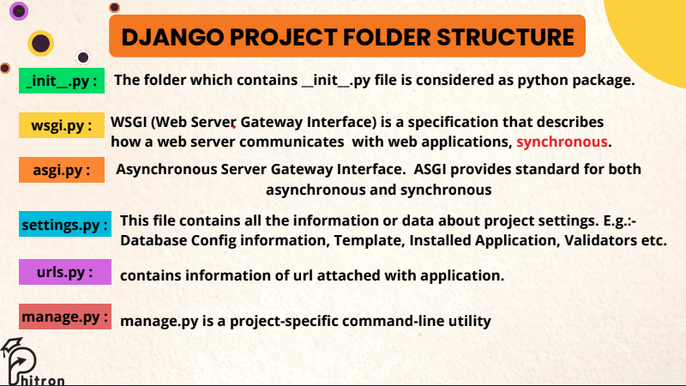

Wsgi.py: synchronous: ekta kaj ses na kore arektai jai na.

Asgi.py: both synchronous and asynchronous: same website multiple tab e open kore multiple kaj korte partesi.

Settings.py: main jaan of Django

Manage.py: ekta project run korte etar help nite hoi

Project vs Application: project boro part. Project er choto choto vag gula holo application. Application is not independent. Project er 2000 line er code ke alada alada app e vag kore alada file e Rakha.

Commands:

* For creating a project:
  + Django-admin startproject project_name
* For creating an application:
  + Django-admin startapp app_name

Jemon school project e students, courses ekekta app.

Project e views.py thake na, manually banai nite hoi. Application e urls.py thake na, banai nite hoi.

* Ekta project e startapp command diye app create korar por CEO(settings.py) ke janate hobe must. Settings.py -> installed apps -> ‘app_name’,

What is git?

Git is a version control system or tool used for tracking changes in computer files. Installed locally on pc. Generally used for source code management.

Github: code hosting platform for version control and collaboration. Kind of cloud based hosting service.